**Misspecification Bias**

**Anscombe's Quartet**

|  |  |  |  |  |  |  |  |  |  |  |  |
| --- | --- | --- | --- | --- | --- | --- | --- | --- | --- | --- | --- |
|  | **x1** | **y1** |  | **x2** | **y2** |  | **x3** | **y3** |  | **x4** | **y4** |
| 1 | 10 | 8.04 |  | 10 | 9.14 |  | 10 | 7.46 |  | 8 | 6.58 |
| 2 | 8 | 6.95 |  | 8 | 8.14 |  | 8 | 6.77 |  | 8 | 5.76 |
| 3 | 13 | 7.58 |  | 13 | 8.74 |  | 13 | 12.74 |  | 8 | 7.71 |
| 4 | 9 | 8.81 |  | 9 | 8.77 |  | 9 | 7.11 |  | 8 | 8.84 |
| 5 | 11 | 8.33 |  | 11 | 9.26 |  | 11 | 7.81 |  | 8 | 8.47 |
| 6 | 14 | 9.96 |  | 14 | 8.1 |  | 14 | 8.84 |  | 8 | 7.04 |
| 7 | 6 | 7.24 |  | 6 | 6.13 |  | 6 | 6.08 |  | 8 | 5.25 |
| 8 | 4 | 4.26 |  | 4 | 3.1 |  | 4 | 5.39 |  | 19 | 12.5 |
| 9 | 12 | 10.84 |  | 12 | 9.13 |  | 12 | 8.15 |  | 8 | 5.56 |
| 10 | 7 | 4.82 |  | 7 | 7.26 |  | 7 | 6.42 |  | 8 | 7.91 |
| 11 | 5 | 5.68 |  | 5 | 4.74 |  | 5 | 5.73 |  | 8 | 6.89 |
| Mean | 9 | 7.5 |  | 9 | 7.5 |  | 9 | 7.5 |  | 9 | 7.5 |
| Variance | 11 | 4.12 |  | 11 | 4.12 |  | 11 | 4.12 |  | 11 | 4.12 |
| Correlation | 0.816 | |  | 0.816 | |  | 0.816 | |  | 0.816 | |
| Regression | **y = 3 + 0.5x** | |  | **y = 3 + 0.5x** | |  | **y = 3 + 0.5x** | |  | **y = 3 + 0.5x** | |
|  |  |  |  |  |  |  |  |  |  |  |  |
|  |  |  |  |  |  |  |  |  |  |  |  |

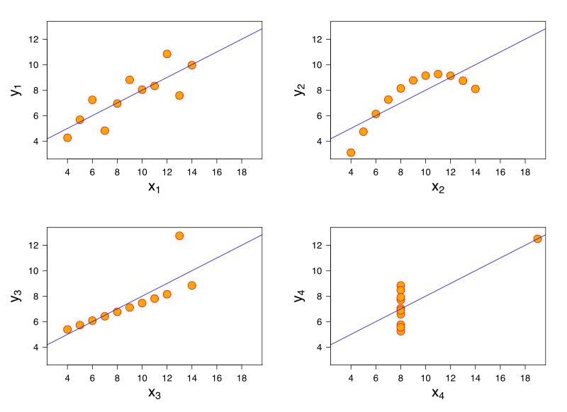

*(Borrowed from wikipedia: Anscombe's Quartet )*